**EX NO 1a: DATE:25.01.2025**

**NAME: TARUN C**

**ROLL NO: 230701358**

**INTRODUCTION TO FIGMA**

**AIM:**

To create a mobile app design in Figma and compare good design with bad design.

**THEORY:**

Figma is a web-based design tool for creating user interfaces, prototypes, and designs. It enables real-time collaboration, vector editing, and cross-platform access. Figma supports design systems, interactive prototyping, and an extensive library of plugins, making it perfect for teams.

**PROCEDURE:**

**Step 1: Create a New file**

1.Click “New File” to start a blank project.

**Step 2: Create the Frame (Artboard)**

1. On the left toolbar, select the “Frame” tool (shortcut: F).

2. Choose a mobile preset (e.g., iPhone 13) from the right-hand panel.

3. A mobile-sized frame will appear on the canvas, which will act as your app screen.

**Step 3: Design the Login Screen**

**Add a Background Color:**

1. Select the frame and go to the right-side panel.

2. Under “Fill” choose a background color

**Insert a Logo:**

1. Click the “Rectangle” tool (shortcut: R) and draw a placeholder for a logo.

2. Use the “Text” tool (shortcut: T) to add your app name,

3. Adjust font size and color from the right-hand panel.

**Add Input Fields:**

1. Use the “Rectangle” tool to draw two boxes for username and password fields.

2. Add placeholder text inside

3. Apply rounded corners under “Corner Radius” in the right panel.

**Add a Login Button:**

1. Create a button using the “Rectangle” tool

2. Add the text “Login” inside the button.

**Step 4: Prototyping the Interaction**

1. Click the “Prototype” tab on the right panel.

2. Select the “Login” button and drag the blue dot to a new frame (e.g., a home

screen).

3. Set the interaction to “On Click” → &”Navigate to” the next screen.

4. Choose an animation effect

**Step 5: Preview the Design**

1. Click the “Play” button in the top-right corner to preview your app prototype.

2. Try clicking on the login button to see the transition to the next screen.

**OUTPUT:**

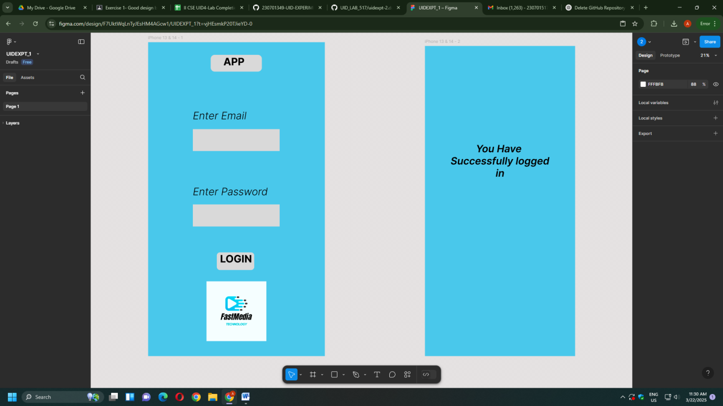

**BAD DESIGN:**

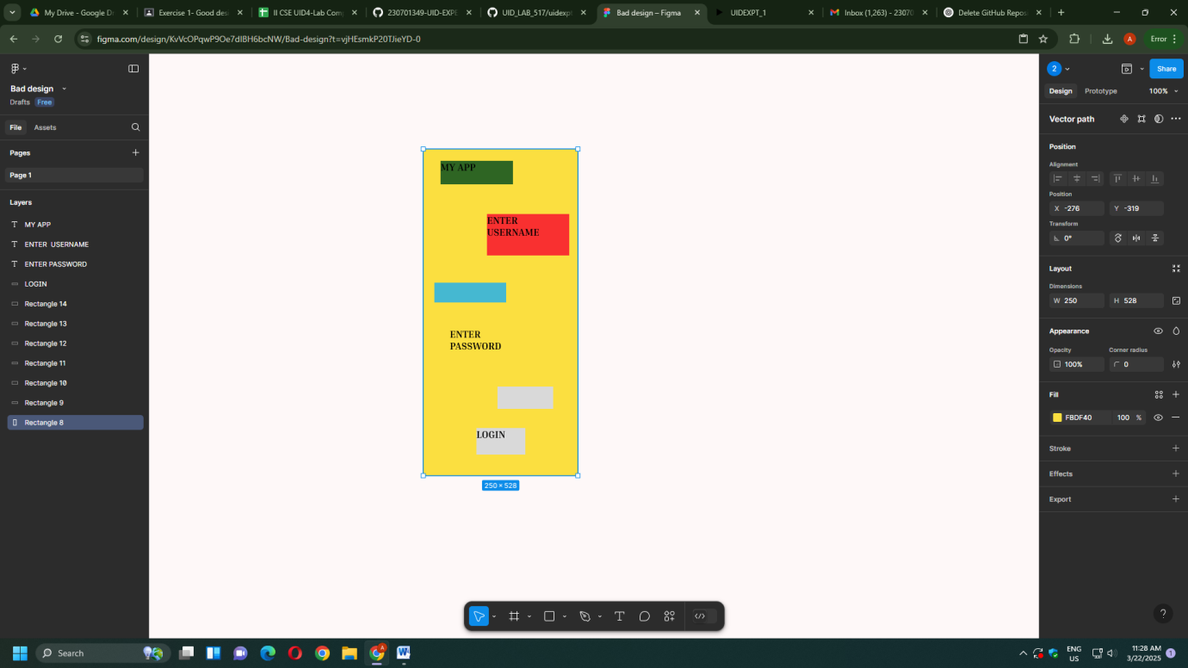

**REASON:**

This design lacks proper alignment, resulting in inconsistency, and fails to communicate a clear message to the user. The absence of structure makes it difficult for users to navigate or understand the content, leading to a poor user experience.

**GOOD DESIGN:**

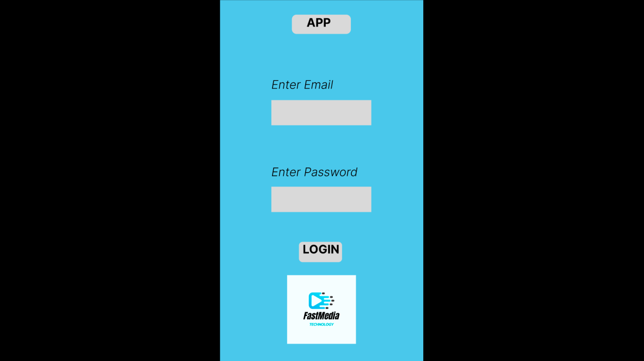

**REASON:**

This design could benefit from improved alignment to create a more consistent and visually appealing structure. With clearer messaging and better organization, users would find it easier to navigate and understand the content, leading to an enhanced user experience.

**FIGMA DESIGN FILE:**

[DESIGN_FILE](https://www.figma.com/proto/F7UktWqLnTyJEsHM4AGcw1/UIDEXPT_1?t=vjHEsmkP20TJieYD-0&scaling=scale-down&content-scaling=fixed&page-id=0%3A1&node-id=1-2&starting-point-node-id=1%3A2)

**RESULT:**

Hence , introduction to figma and creating a app design and comparison of good design and bad design using figma have been studied successfully.